Book

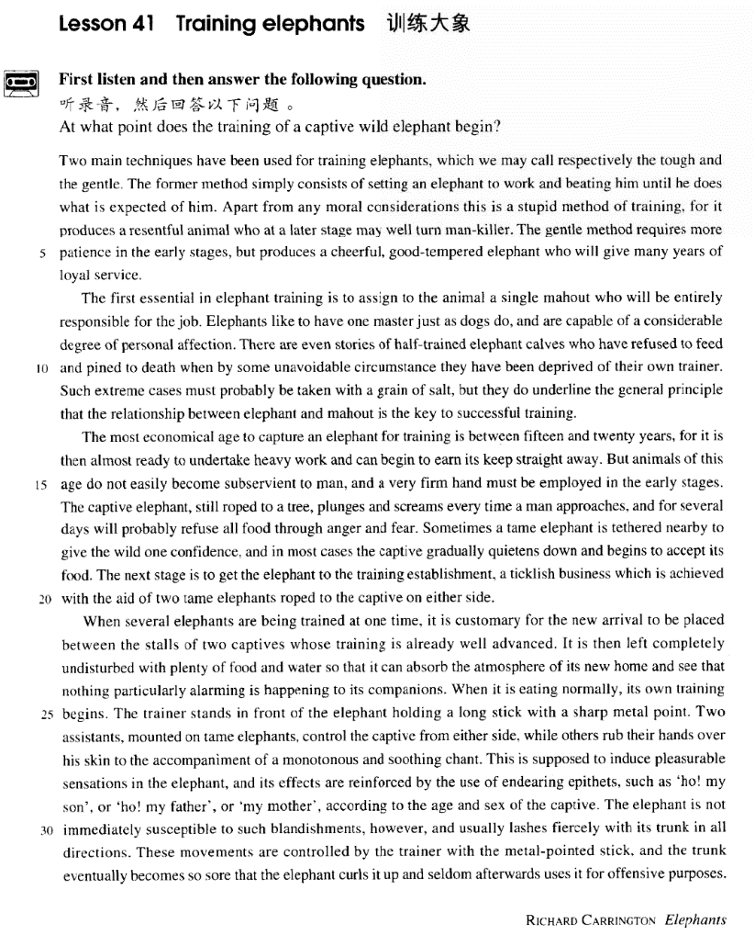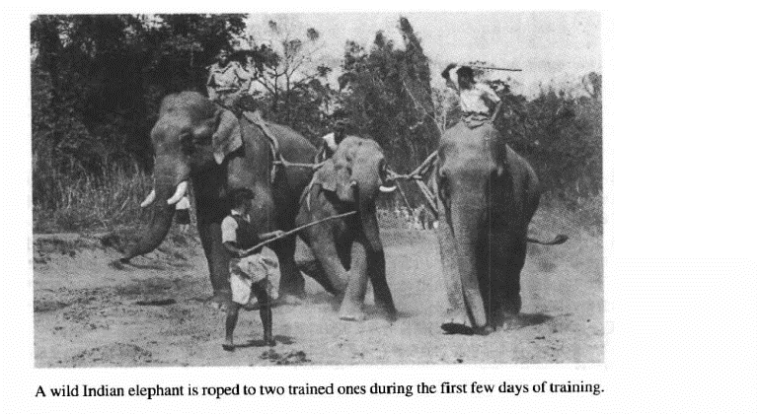

课文

Two main techniques have been used for training elephants, which we may call respectively the tough and the gentle.

驯象有两种主要的方法，我们分别称之为强硬法和温柔法。

The former method simply consists of setting an elephant to work and beating him until he does what is expected of him.

强硬法就是驱象去干活，把它打顺从为止。

Apart from any moral considerations this is a stupid method of training,

且不说道义问题，这本身就是一种愚蠢的训练方法，

for it produces a resentful animal who at a later stage may well turn man-killer.

因为这种方法训练会使动物反感，在以后某个时期可能会变成伤人的动物。

The gentle method requires more patience in the early stages,

温柔法要求在最初阶段保持较大的耐心，

but produce a cheerful good-tempered elephant who will give many years of loyal service.

但这种方法可以训练出性情愉快、脾气温顺，能忠实为人服务多年的大象。

The first essential in elephant training is to assign to the animal a single mahout who will be entirely responsible for the job.

驯象中至关生要的是指派一名专门的驯象员，全面负责这项工作。

Elephants like to have one master just as dogs do, and are capable of a considerable degree of personal affection.

大象和狗一样，喜欢有一个专一的主人，而且会对主人产生相当深厚的私人感情。

There are even stories of half-trained elephant calves who have refused to feed and pined to death when by some unavoidable circumstance they have been deprived of their own trainer.

甚至有这样的故事：训练了一半的小象，由于不可避免的情况与他们的主人分离后，竟拒绝吃食，消瘦至死。

Such extreme cases must probably be taken with a grain of salt,

这种极端的事例虽不可全信，

but they do underline the general principle that the relationship between elephant and mahout is the key to successful training.

但强调了一项基本原则，象和驯象员之间的关系是驯象成功与否的关健。

The most economical age to capture an elephant for training is between 15 and 20 years,

捕捉15至20岁之间年龄的大象进行驯象最为经济。

for it is then almost ready to undertake heavy work and can begin to earn its keep straight away.

这个年龄的象差不多已能干重活，可以很快挣回饲养它的开支。

But animals of this age do not easily become subservient to man, and a very firm hand must be employed in the early stages.

但这个年龄的象不易驯服，因此开始阶段需要有一位强有力的老手。

The captive elephant, still roped to a tree, plunges and screams every time a man approaches, and for several days will probably refuse all food through anger and fear.

捕来拴在树上的大象，每当有人走近它时，就会向前猛冲并发出尖叫，甚至一连几于都由于愤怒和恐惧而拒绝进食。

Sometimes a tame elephant is tethered nearby to give the wild one confidence,

有时，把一头已驯服的象拴在旁边能给野象以信心。

and in most cases the captive gradually quietens down and begins to accept its food.

在大多数情况下，刚博来的象会慢慢静下来，接着开始吃食。

The next stage is to get the elephant to the training establishment,

下一步就是把象带到训练场所，

a ticklish business which is achieved with the aid of two tame elephants roped to the captive on either side.

这是一件棘手的事，需要在它两侧拴上两头驯服的大象才能完成。

When several elephants are being trained at one time, it is customary for the new arrival to be placed between the stalls of two captives whose training is already well advanced.

几只象同时训练时，通常是把新到的安置在两头训练得很好的大象的象厩中间，

It is then left completely undisturbed with plenty of food and water so that it can absorb the atmosphere of its new home and see that nothing particularly alarming is happening to its companions.

然后给它以充足的食物和水，一定不要惊扰它，以便让他能适应新居的气氛，并且看到自己的同伴身上没有发生让自己担惊受怕的事。

When it is eating normally, its own training begins.

当它进食正常了，训练就开始。

The trainer stands in front of the elephant holding a long stick with a sharp metal point.

驯练员手持一根有锋利金属尖头的长棒，站在象前。

Two assistants, mounted on tame elephants, control the captive from either side,

两位助手骑在驯服的象的背上，从两侧控制新捕的象，

while others rub their hands over his skin to the accompaniment of a monotonous and soothing chant.

其他人唱着单调的歌声用手抚摸象的皮肤。

This is supposed to induce pleasurable sensations in the elephant, and its effects are reinforced by the use of endearing epithets,

据说这是为了使象产生愉快的感觉，为了加强这种效果，

such as 'ho! my son', or 'ho! my father', or 'my mother', according to the age and sex of the captive.

人闪还按象的年龄性别，给以亲切的外号，如“嗬！我的孩子”、“嗬！我的爸爸”、“嗬！我的妈妈”。

The elephant is not immediately susceptible to such blandishments, however, and usually lashes fiercely with its trunk in all directions.

然而大象不会立刻被这些讨好的括感动，而往往是用鼻子朝各个方向猛烈地甩动。

These movements are controlled by the trainer with the metal-pointed stick,

训练员要用有锋利金属尖的长棒控制它的这种举动，

and the trunk eventually becomes so sore that the elephant curls it up and seldom afterwards uses it for offensive purposes.

象鼻子最后疼得卷了起来，以后它就很少用鼻子去进攻了。

词汇讲解

Lesson 41 Training elephants

resentful [rɪ'zentfl] adj. 怨恨的

resentful adj. feeling angry and upset about sth. that you think is unfair

怨恨的

a resentful look / expression / voice

resentful of / about / at …

She felt resentful at not being promoted.

They seemed to be resentful of our presence there. At first I felt very resentful about losing my job.

resent v. to feel angry or upset about a situation or about sth. that sb. has done, esp. because you think that it is not fair 怨恨

I bitterly resent your criticism.

Does she resent my being here? “sens” / “sent” = to feel

resent “re” = back v. 怨恨

resentful adj. 怨恨的resentment n. 怨恨sensation n. 轰动；感觉sensational adj. 轰动性的

sense n. 感觉，知觉；意义

sensitive adj. 敏感的

sensual adj. 肉体上的；性感的sentiment n. 情绪，感情sentimentality n. 多愁善感

assent “as” / “ad” = to v. & n. 同意，赞成consent “con” = together v. & n. 同意，赞成consensus n. 共识

dissent “dis” = apart n. 异议，反对；v. 持异议，不同意

presentiment “pre” = before n. 预感，凶兆

assign [ə'sain]

v. 分配；指派

assign v. 1. give sth. to sb. as a share of work to be done or of things to be used 分配，安排

assign sb. sth.

The teacher has assigned each of us a holiday task. assign sth. to sb.

The two large classrooms have been assigned to us.

The teacher assigned a different task to each of the children.

assign v. 2. to provide a person for a particular task or position 指派

assign sb. to do sth.

British forces have been assigned to help with peacekeeping. assign sb. to sth.

Two senior officers were assigned to the investigation. They've assigned their best man to the job.

The first essential in elephant training is to assign *to the animal* a single

mahout who will be entirely responsible for the job. “sign” = to mark

assign “as” / “ad” = to v. 分配；指派

assignment n. 分配；任务，作业

signature n. 签字

signify “fy” / “fac” / “fic” = make v. 表示，表明significant adj. 重要的；有意义的significance. n. 重要性；意义

consign “con” = together v. 委托，托付；托运

consignment n. 委托，托付；托运，托运的货物

design “de” = down v. 设计；计划；n. 设计，设计图；计划，方案

designate v. 指定，委任；命名designation n. 委任；名称，称呼resign “re” = again v. 辞职；顺从resignation n. 辞职，辞呈；顺从

calf [kɑ:f] [kæf]

n. 小牛或其他大型动物的幼崽

calf n. (pl calves) the baby of a cow, or of some other large animals, such as an elephant, a giraffe, a whale, a seal, a dolphin etc. 小牛或其他大型动物的幼崽（如小象，小长颈鹿，小鲸鱼，小海豹，小海豚等） One young calf especially enjoyed raising a turtle to the surface with his

snout and then shoving him across the tank like an aquaplane. foal n. 小马，小驴

piglet n. 小猪

lamb n. 小绵羊kid n. 小山羊fawn n. 小鹿

cub n.（狐、熊、狮、虎等的）幼兽kitten n. 小猫

puppy n. 小狗chicken n. 小鸡duckling n. 小鸭gosling n. 小鹅larva n. 幼虫infant n. 婴儿

underline [7ʌndə'laɪn]

v. 在下面划线；强调，使突出

underline v. 1. to draw a line under a word, sentence, etc. = underscore

在下面划线

The names of the winners are underlined in red.

underline v. 2. to show that something is important = underscore 强调， 使突出

This tragic incident underlines the need for immediate action. emphasize / stress v. 重读；强调，使突出

The shop assistant looked puzzled and Harry repeated the word, slowly

stressing each syllable.

The report emphasizes the importance of improving safety standards. I must stress that everything I've told you is strictly confidential.

put / lay emphasis / stress on sth.

We should put greater emphasis on employee development.

We would lay less stress on 'facts and figures' and more on a good memory, on applied psychology, and on the capacity of a man to get along with his fellow-citizens.

accentuate v. 重读；强调，使突出

Her dress was tightly belted, accentuating the slimness of her waist.

highlight v. 用荧光笔标出重点；强调，使突出

Your resume should highlight your skills and achievements. subservient [səb'sɜ:viənt]

adj. 屈从的，顺从的

subservient adj. too willing to obey other people 屈从的，顺从的

subservient to …

The press was accused of being subservient to the government.

But animals of this age do not easily become subservient to man, and a very firm hand must be employed in the early stages.

submissive adj. 服从的，顺从的

They never become submissive like dogs and horses. obedient adj. 服从的，顺从的

an obedient child

He was always obedient to his father's wishes. compliant adj. 服从的，顺从的

She was much naughtier than her compliant brother.

law-abiding adj. 守法的law-abiding citizens soothe [su:ð]

v. 使平静，安慰，抚慰

soothe v. to make someone feel calmer and less anxious, upset, or angry

使平静，安慰，抚慰

Lucy soothed the baby by rocking it in her arms.

soothing adj. making you feel calm 安慰性的，令人镇定的

I put on some nice soothing music. Her words had a soothing effect.

console v. to make someone feel better when they are feeling sad or disappointed 安慰

The following day, however, the doctor consoled him by telling him that

his chances of being able to leave hospital in time for New Year celebrations were good.

What you said about George was very consoling.

He nodded and put a consoling arm around her shoulders.

reassure v. to say or do sth that makes sb. less frightened or worried 安慰，使放心

They tried to reassure her, but she still felt anxious.

The doctor reassured him that there was nothing seriously wrong. The teacher gave him a reassuring smile.

It's reassuring to know that problems are rare. epithet ['epɪθet]

n. 称呼，称号，绰号

epithet n. a word or short phrase used to describe sb., esp. when praising them or saying sth. unpleasant about them 称呼，称号，绰号

In ‘Alfred the Great’, ‘the Great’ is an epithet.

The film is long and dramatic but does not quite earn the epithet ‘epic’. “epi”= upon / to / besides / among

epithet “epi”= upon “thet” = put n. 称呼，称号，绰号

epitaph “epi”= upon “taph” = tomb n.祭文，悼词，墓志铭epigraph “epi”= upon “graph” = write n. 碑文

epitome “epi”= to “tome” = cut n. 梗概，缩影；典型，典范

epilogue “epi” = besides “logue” = speech n. 后记，跋；收场白episode “epi” = besides “sode” = coming in n. 插曲，轶事；（电视或广播节目的）一集

epidemic “epi” = among “dem” = people n. 传染病的流行

Two main techniques have been used for training elephants, which we may call respectively the tough and the gentle.

be used for …

This increases the expense of government, and reduces correspondingly the amount of economic resources that could be used for developing the country.

Some hotels supply boiled water on request and this can be used for drinking, or for brushing teeth.

respectively adv. in the same order as the things you have just mentioned

各自，分别

The cups and saucers cost £5 and £3 respective ly. respective adj. 各自的，分别的

They each excel in their respective fields.

After the party we all went back to our respective homes. respectable adj. 体面的，正派的

a respectable citizen / family

We often read in novels how a seemingly respectable person or family has some terrible secret which has been concealed from strangers for years.

respected adj. 受敬仰的，有名望的

a highly respected surgeon respectful adj. 尊敬的，尊重的

You should be more respectful of other people’s points of view.

respecting prep. 关于……

= concerning / regarding

造句：在这篇有关科学家的文章中，作者特别尊重那些不但是体面正派的公民，而且在各自的领域中都深受敬仰的专家。

In the article respecting scientists, the writer is particularly respectful of those who are not only respectable citizens, but respected experts in their respective fields.

The former method simply consists of setting an elephant to work and beating him until he does *what is expected of him*.

set sb. to work (doing sth.): to make sb. do work for you, esp. when they do not want to do this 让某人工作（尤指对方不情愿的情况下） Don't complain that you're bored, or Dad will set you to work.

I've set them to work clearing out the garage. expect … of sb. 对某人希望……

I can't finish this job by Friday you expect too much of me.

The school expects a lot of its students.

*Apart from any moral considerations* this is a stupid method of training, for it produces a resentful animal who at a later stage may well turn

man-killer.

apart from / aside form 1. except for 除了

Apart from a few words, I do not know any French at all. apart from / aside form 2. besides 除了……（还……）

Apart from an interesting-looking carved dagger, the box was full of

crockery, much of it broken.

Your behavior reflects on me, and I can't do my job if you're constantly

humiliating me.

Constantly? Aside from today, give me one example. apart from / aside form 3. separate from 脱离开……

He must, for example, perceive an egg as a simple single solid shape,

quite apart from its significance as food, or from the literary idea that it will become a bird.

consideration n. [C] thing that must be thought about or taken into account, reason 考虑到的事，原因，因素

economic / commercial / environmental / practical considerations

Several considerations have influenced my decision.

Political rather than economic considerations influenced the location of the new factory.

method of / for (doing) sth.

… if there is any effect of noise upon mental health, it must be so small that present methods *of* psychiatric diagnosis cannot find it.

There is no quicker method *of* disposing of patients then by giving them what they are asking for, …

Those planning a trip to remote areas, or intending to live in countries where drinking water is not readily available, should know about the various possible methods *for* making water safe.

may / might / could well … used to say that sth. is likely to happen or is

likely to be true （某事）可能（发生或是真的）

Another patient might equally well complain that her neighbours were combining to slander her and persecute her, and yet one might be cautious about believing this statement.

… and the railway of the future may well be the 'hovertrain', …

Over the years one may well become an authority on one's hobby and will very probably be asked to give informal talks to little gatherings and then, if successful, to larger audiences.

turn v. become 变成（不加冠词）

He has turned traitor.

He used to be a teacher till he turned writer.

She was betrayed by a childhood friend who turned government informant.

The gentle method requires more patience in the early stages, but

produces a cheerful, good-tempered elephant who will give many years of loyal service.

cheerful adj. willing to do whatever is necessary in a happy way 乐意的，

肯干的

a cheerful worker

I’ll do everything I can to help you, she said with a cheerful grin.

service n. [U or pl.] the work that sb. does for a person or organization, esp. over a long period 工作

Jack was given a gold watch after 25 years of loyal service.

an award for her services to the community

The first essential *in elephant training* is *to assign to the animal a single mahout who will be entirely responsible for the job*.

essential n. [C] fundamentally necessary element or thing 要素，要点，

必需品

A knowledge of French is an absolute essential. the essentials of English grammar

food, water, and other essentials assign sb. to sth.

The first essential in elephant training is to assign *to the animal* a single

mahout who will be entirely responsible for the job.

Elephants like to have one master *just as dogs do*, and are capable of a considerable degree *of personal affection*.

It was not forced upon them by the survival competition; they could have caught and lived on prey without using poison, just as the thousands of non-poisonous snakes still do.

affection n. a feeling of liking for a person or place 感情，柔情，喜爱

affectionate adj. 有感情的，充满柔情的

They can be friendly and affectionate towards humans, but they lead mysterious lives of their own as well.

There are even stories of half-trained elephant calves who have refused to feed and pined to death *when by some unavoidable circumstance they have been deprived of their own trainer*.

And then, when they were dead, the carnivores, like the sabre-toothed cats and the giant wolves, came out to feed and suffered exactly the same fate.

After all, all living creatures live by feeding on something else, …

It tires not, nor does it boast of its power; but belongs to the air, travelling it may be six thousand miles to and from its northern nesting home, feeding its flown young as it flies, …

pine v. be very unhappy, esp. because sb. has died or gone away 痛苦，伤

心（尤指因生离死别）

Six months after he left, she was still pining. do sth. by mistake / accident

I succeeded by good fortune.

By mere negligence she had seriously wounded the feelings of Maggie. Such extreme cases must probably be taken with a grain of salt, but they do underline the general principle that the relationship between elephant

and mahout is the key to successful training.

take sth. with a grain / pinch of salt: to doubt the truth or value of sth. 怀疑……的真实性或价值，有保留地相信或接受……

If I were you, I'd take his advice with a grain of salt. Most of what he says should be taken with a pinch of salt. the relationship between teacher and student

the conflict between mother and son

Primarily, the banker-customer relationship is that of debtor and creditor …

be / hold the key to … 是……的关键

Working well as a team is the key to success .

a discovery that may hold the key to our understanding of the universe

造句：这种极端的例子虽不可全信，但是却的确突出了这一基本原则： 夫妻关系是成功婚姻的关键。

Such extreme cases must probably be taken with a grain of salt, but they do underline the general principle that the relationship between husband and wife is the key to successful marriage.

The most economical age *to capture an elephant for training* is between fifteen and twenty years, for it is then almost ready to undertake heavy work and can begin to earn its keep straight away.

be ready to do sth. 可以……

The contract will be ready to sign in two weeks.

The computer is now set up and ready to use.

keep n. [U] the cost of providing food and a home for someone 生活费

We only need two rooms and our keep. earn sb.’s keep 赚回生活费

It's time you got a job and started earning your keep.

Does that old car still earn its keep?

straight away adv. immediately 立刻，马上

They can't pay me straight away.

I knew straight away it was a bad injury.

But animals *of this age* do not easily become subservient to man, and a very firm hand must be employed *in the early stages*.

hand n. a person skilled in a particular action or pursuit 某方面的能手

He is a good hand with a gun.

She was a fabulous hand at embroidery.

It was easy to see that he was an old hand at the job.

The captive elephant, *still roped to a tree*, plunges and screams every time a man approaches, and *for several days* will probably refuse all food *through anger and fear*.

plunge v. to move, fall, or be thrown suddenly forwards or downwards

猛冲或突然落下

He plunged toward the door and wrenched it open.

She lost her balance and plunged 100 feet to her death.

The order to abandon ship was given and hundreds of people plunged into the icy water.

through prep. 因为，由于……

We missed the plane through being held up on the motorway. The vase was broken through carelessness.

Sometimes a tame elephant is tethered nearby *to give the wild one*

*confidence*, and in most cases the captive gradually quietens down and

begins to accept its food.

tame adj. a tame animal or bird is not wild any longer, because it has been trained to live with people 驯化的

tether v. to tie an animal to a post so that it can only move around within a

limited area 把动物拴住

He tethered his horse to a tree.

quieten v. to become calmer and less noisy or active, or to make sb. or sth. do this（使）平静些, 安静些

quieten a screaming baby

The chatter gradually quietened. quieten down

Quieten down and get ready for bed!

The next stage is *to get the elephant to the training establishment*, a

ticklish business which is achieved with the aid of two tame elephants

*roped to the captive on either side*.

get v. to make sth. or sb. move to a different place or position, esp. with some difficulty

I couldn't get the disk out of the computer.

Could you help me get the wardrobe up the stairs?

We must get food and emergency aid into the area as quickly as possible. establishment n. [C] a business or other organization, or the place where it operates 公司、机构或其场所

a / an educational / financial / religious establishment

a top class training establishment

ticklish adj. 1. sensitive to tickling 怕痒的

I'm terribly ticklish.

ticklish adj. 2. a ticklish problem, situation, or task is difficult and needs to be dealt with carefully 难解决的，需小心处理的

a ticklish question

in a ticklish situation

business n. 1. [U] things that need to be done or discussed（需要做或讨论的）事

Okay, let's get down to business. It’s none of your business.

business n. [sing.] (usually with an adj. 常与形容词连用) (often derog.

常作贬义) a matter, an event or a situation 事情，情况

Arranging a trip abroad is a *time-consuming* business. These killings are a *dreadful* business.

That plane crash was an *awful* business.

When several elephants are being trained at one time, it is customary *for the new arrival* to be placed between the stalls of two captives whose

training is already well advanced.

at one time 1. if sb. does two or more things at one time they do them at the same time, esp. if this is difficult or impressive 同时

This word processor allows you to work with two documents at one time.

You're trying to do too many things at one time.

at one time 2. at a time in the past but not now 过去，以前

At one time she wanted to be a nurse, but the thought of working at night put her off.

customary adj. according to custom, usual 合乎习俗的，依照习俗的，

习惯上的

it is customary (for sb.) to do sth.

Is it customary to tip hairdressers in this country?

In some cultures it is customary for the bride to wear white.

In my village, it is customary for a girl to take her mother's name.

arrival n. [C] person or thing that arrives 到达的人或物

Late arrivals must wait in the foyer.

We're expecting a new arrival in the family soon.

stall n. an enclosed area in a building for an animal such as a horse or cow 牲畜棚中的一栏

All the cattle had been moved into stalls and we stood to lose little.

It is then left completely undisturbed with plenty of food and water so that it can absorb the atmosphere of its new home and see *that nothing*

*particularly alarming is happening to its companions*.

leave v. if you leave sth. in a particular condition you do not touch it, move it or act to change it in any way 使或让……处于某状态

You can leave the window open.

Leave your sister alone.

It’s better to leave some things *unsaid*.

He got up slowly leaving the lunch *unfinished*.

Please excuse me if I have left any of your questions *unanswered*.

absorb v. to take sth. into the mind and learn or understand it 理解，接受，熟悉

It's a lot of information to absorb all at once.

It took me several days to absorb the fact of her death. They spent a week in Paris just absorbing the atmosphere.

alarming adj. making you feel worried or frightened 令人惊恐的

an alarming increase in violent crime

The rainforest is disappearing at an alarming rate. When it is eating normally, its own training begins.

The trainer stands in front of the elephant holding a long stick with a

sharp metal point.

Two assistants, mounted on tame elephants, control the captive *from*

*either side*, while others rub their hands over his skin to the accompaniment of a monotonous and soothing chant.

mount v. 1. go up, ascend 登上

He mounted the platform and addressed the crowd.

mount v. 2. to fix sth. into position on sth., so that you can use it, look at it or study it 将某物固定住（以备使用、展示或研究）

Triple gun-decks mounted sixty-four bronze cannon.

mount v. 3. to increase gradually 逐渐增加

This modern faith in medicines is proved by the fact that the annual drug bill of the Health Services is mounting to astronomical figures and shows no signs at present of ceasing to rise.

mount v. 4. get onto or put sb. onto a horse, etc. for riding（使）骑上马等

He quickly mounted his horse and rode away. He mounted the boy on the horse.

The policemen were mounted on black horses. accompaniment n. 伴奏；伴随物

to the accompaniment of sth. 1. while a musical instrument is being

played 在……的伴奏之下

They performed to the accompaniment of guitars. The girls sang to the accompaniment of a piano.

to the accompaniment of sth. 2. while sth. else is happening or can be heard 在……发生时，在……声中

She made her speech to the accompaniment of loud laughter.

Franco left the chamber to the accompaniment of loud applause.

chant n. words or phrases that a group of people shout or sing again and again 一群人反复唱或喊叫的词语，口号

The team's supporters sang a victory chant.

This is supposed to induce pleasurable sensations in the elephant, and its effects are reinforced *by the use of endearing epithets, such as ‘ho! my*

*son', or 'ho! my father', or 'my mother', according to the age and sex of the captive*.

be supposed to do sth. 1. used to say that sth. is believed to be true by many people, although it might not be true or you might disagree 据说， 据称

The castle is supposed to be haunted.

Mrs. Carver is supposed to have a lot of money. be supposed to do sth. 2. 应该；本该

What time are you supposed to be there?

The meeting was supposed to take place on Tuesday, but we've had to postpone it.

He's supposed to go to the meeting.

He wants the woman to give George the message.

He doesn't know why George can't attend the meeting.

He forgot to deliver a message.

W: Do you know if George is coming to the meeting?

M: Oh, no, I was supposed to tell you that he is sick and can’t come. Q: What does the man mean?

Answer: (D) He forgot to deliver a message.

sensation n. 1. a feeling that you get from one of your five senses, esp. the sense of touch 感觉（尤指触觉）

One sign of a heart attack is a tingling sensation in the left arm.

sensation n. 2. state of great surprise, excitement, interest, etc. among many people 轰动

cause a sensation

The first tests on the Solent in 1959 caused a sensation.

reinforce v. to make a feeling, an idea, etc. stronger 加强，强化

The experience reinforced my sense of loss.

Success in the talks will reinforce his reputation as an international statesman.

endearing adj. making someone love or like you 惹人喜爱的

Shyness is one of her most endearing qualities.

The elephant is not immediately susceptible to such blandishments,

*however*, and usually lashes fiercely *with its trunk in all directions*. be susceptible to sth. 1. 易患某病的

Scientists discovered that this particular variety of rabbit (and apparently

no other animal) was susceptible to a fatal virus disease, myxomatosis. be susceptible to sth. 2. 易受……影响的

Young people are the most susceptible to advertisements.

James was extremely susceptible to flattery.

blandishment n. [usu pl] (fml.) flattering or coaxing words and actions 谄媚或哄骗的言语和行为

She resisted his blandishments.

lash v. to move or to move sth. quickly and violently from side to side 猛烈地甩动

The crocodile's tail was lashing furiously from side to side.

These movements are controlled by the trainer *with the metal-pointed*

*stick*, and the trunk eventually becomes *so* sore that the elephant curls it

up and seldom afterwards uses it for offensive purposes. pointed adj. having a sharp end 尖的

a pointed chin

pointed teeth

for … purposes 出于……的需要

These gifts count as income for tax purposes.

For our purposes, we are concerned only with one kind of cost ― the cost of managing and administering the business.